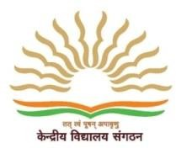

PM SHRI KENDRIYA VIDYALAYA NO 2 AFS Srinagar
Admission Notice for Balvatika- III 2024-25
- Balvatika–3 Admissions will be done through offline mode. Registration will commence at 10:00 am on 01.04.2024 (Monday) and will close at 05:00 pm on 15.04.2024 (Monday). Willing parents may get Registration form from the Vidyalayas on working day by showing birth certificate of child and residence proof of the parent, or download from vidyalaya website.
- Minimum age for admission in Balvatika-3 will be 5 years. Reckoning of age for all Balvatika Classes shall be as on 31.03.2024 (Child born on 1st April will also be considered). The maximum age limit can be relaxed by two years in case of Children with Special Needs (CWSN).
- Admission will be given as per priority category and reservation norms as mentioned in Admission Guidelines 2024-25.
- Admission will not be granted, if wrong and misleading information in the application form is found at the time of scrutiny by the KV.
- Parents may Contact to Principal/Admission In-charge, only when they called, in the given time slot.
- Other information related to Admission like admission guidelines, admission schedule, lottery list etc. will be updated time to time on Vidhyalaya's websites : http //no2srinagar.ac.in

PRINCIPAL

